727721euit126

RASIKA B

Rest API-CA1

Question No:1

Controller:

**package** com.example.demo.controller;

**import** java.util.List;

**import** org.springframework.beans.factory.annotation.Autowired;

**import** org.springframework.web.bind.annotation.GetMapping;

**import** org.springframework.web.bind.annotation.PathVariable;

**import** org.springframework.web.bind.annotation.PostMapping;

**import** org.springframework.web.bind.annotation.RequestBody;

**import** org.springframework.web.bind.annotation.RestController;

**import** com.example.demo.model.Address;

**import** com.example.demo.repository.AddressRepo;

@RestController

**public** **class** ApiController {

@Autowired

AddressRepo repository;

@GetMapping("/address")

**public** List<Address> getAddress()

{

**return** repository.findAll();

}

@PostMapping("/address")

**public** String addAdress(@RequestBody Address address)

{

repository.save(address);

**return** "Added";

}

@GetMapping("/address/{address}")

**public** List<Address> get(@PathVariable String address)

{

**return** repository.findByAddress(address);

}

}

Model:

**package** com.example.demo.model;

**import** jakarta.persistence.Entity;

**import** jakarta.persistence.Id;

@Entity

**public** **class** Address {

**private** String employeeName;

**private** String address;

@Id

**private** **int** pincode;

**public** String getEmployeeName() {

**return** employeeName;

}

**public** **void** setEmployeeName(String employeeName) {

**this**.employeeName = employeeName;

}

**public** String getAddress() {

**return** address;

}

**public** **void** setAddress(String address) {

**this**.address = address;

}

**public** **int** getPincode() {

**return** pincode;

}

**public** **void** setPincode(**int** pincode) {

**this**.pincode = pincode;

}

@Override

**public** String toString() {

**return** "Address [employeeName=" + employeeName + ", address=" + address + ", pincode=" + pincode + "]";

}

}

Repository:

**package** com.example.demo.repository;

**import** java.util.List;

**import** org.springframework.data.jpa.repository.JpaRepository;

**import** org.springframework.stereotype.Repository;

**import** com.example.demo.model.Address;

@Repository

**public** **interface** AddressRepo **extends** JpaRepository<Address,Integer>{

**public** List<Address> findAll();

**public** List<Address> findByAddress(String address);

}

Output:

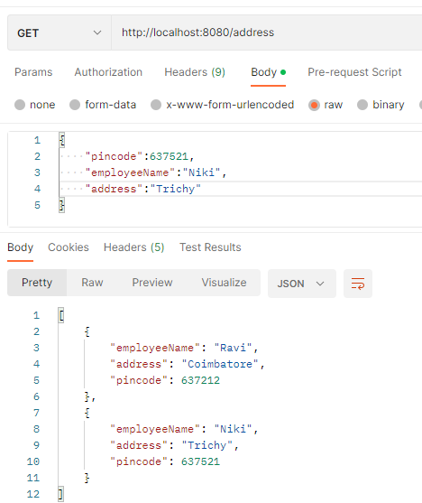

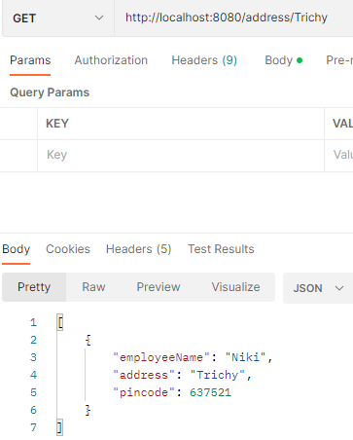

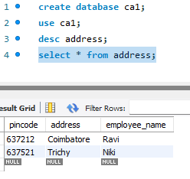

Question 2:

Controller:

**package** com.example.demo.controller;

**import** java.util.List;

**import** org.springframework.beans.factory.annotation.Autowired;

**import** org.springframework.web.bind.annotation.DeleteMapping;

**import** org.springframework.web.bind.annotation.GetMapping;

**import** org.springframework.web.bind.annotation.PathVariable;

**import** org.springframework.web.bind.annotation.PostMapping;

**import** org.springframework.web.bind.annotation.PutMapping;

**import** org.springframework.web.bind.annotation.RequestBody;

**import** org.springframework.web.bind.annotation.RestController;

**import** com.example.demo.model.Student;

**import** com.example.demo.service.ApiService;

@RestController

**public** **class** ApiController {

@Autowired

ApiService service;

@PostMapping("/stu")

**public** String addStudent(@RequestBody Student student)

{

**return** service.addStudent(student);

}

@GetMapping("/stu")

**public** List<Student> read()

{

**return** service.getStudent();

}

@PutMapping("/stu")

**public** Student update(@RequestBody Student student)

{

**return** service.updateStudent(student);

}

@DeleteMapping("/stu/{id}")

**public** String delete(@PathVariable **int** id)

{

**return** service.deleteStudentById(id);

}

}

Model:

**package** com.example.demo.model;

**import** jakarta.persistence.Entity;

**import** jakarta.persistence.Id;

@Entity

**public** **class** Student {

@Id

**private** **int** id;

**private** String studentName;

**private** String departmentName;

**private** String section;

**private** **long** mobile;

**private** String mailid;

**private** String address;

**public** **int** getId() {

**return** id;

}

**public** **void** setId(**int** id) {

**this**.id = id;

}

**public** String getStudentName() {

**return** studentName;

}

**public** **void** setStudentName(String studentName) {

**this**.studentName = studentName;

}

**public** String getDepartmentName() {

**return** departmentName;

}

**public** **void** setDepartmentName(String departmentName) {

**this**.departmentName = departmentName;

}

**public** String getSection() {

**return** section;

}

**public** **void** setSection(String section) {

**this**.section = section;

}

**public** **long** getMobile() {

**return** mobile;

}

**public** **void** setMobile(**long** mobile) {

**this**.mobile = mobile;

}

**public** String getMailid() {

**return** mailid;

}

**public** **void** setMailid(String mailid) {

**this**.mailid = mailid;

}

**public** String getAddress() {

**return** address;

}

**public** **void** setAddress(String address) {

**this**.address = address;

}

@Override

**public** String toString() {

**return** "Student [id=" + id + ", studentName=" + studentName + ", departmentName=" + departmentName

+ ", section=" + section + ", mobile=" + mobile + ", mailid=" + mailid + ", address=" + address + "]";

}

}

Repository:

**package** com.example.demo.repository;

**import** org.springframework.data.jpa.repository.JpaRepository;

**import** org.springframework.stereotype.Repository;

**import** com.example.demo.model.Student;

@Repository

**public** **interface** StudentRepository **extends** JpaRepository<Student,Integer>{

}

Service:

**package** com.example.demo.service;

**import** java.util.List;

**import** org.springframework.beans.factory.annotation.Autowired;

**import** org.springframework.stereotype.Service;

**import** com.example.demo.model.Student;

**import** com.example.demo.repository.StudentRepository;

@Service

**public** **class** ApiService {

@Autowired

StudentRepository repository;

**public** String addStudent(Student student) {

repository.save(student);

**return** "Added";

}

**public** List<Student> getStudent() {

**return** repository.findAll();

}

**public** Student updateStudent(Student student) {

repository.save(student);

**return** student;

}

**public** String deleteStudentById(**int** id) {

repository.deleteById(id);

**return** "Deleted!!..";

}

}

Output:

Post:

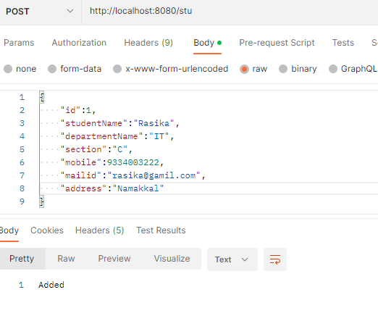

Get:

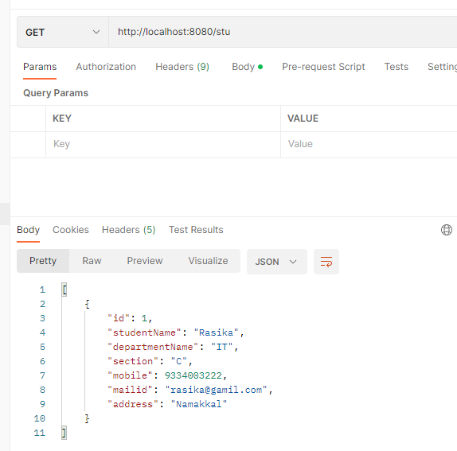

Put:

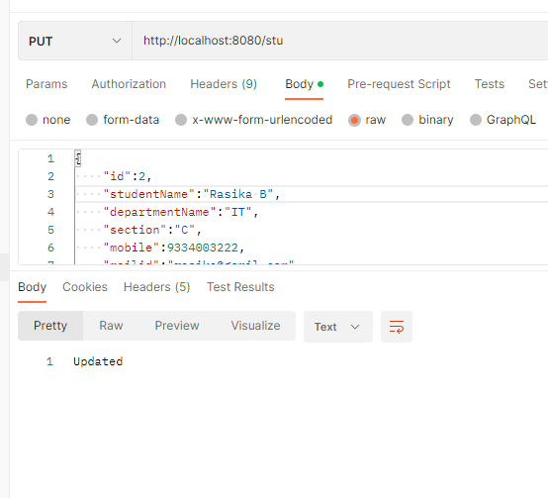

Delete:

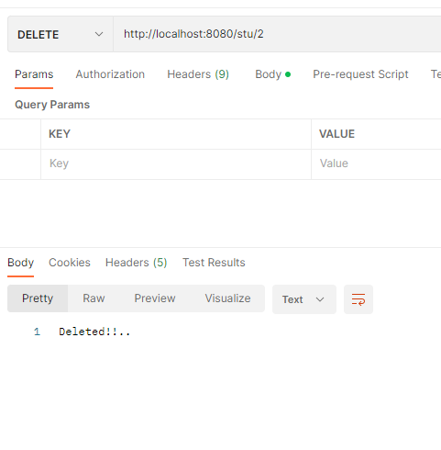

Question 3:

Controller:

**package** com.example.demo.controller;

**import** java.util.List;

**import** org.springframework.beans.factory.annotation.Autowired;

**import** org.springframework.web.bind.annotation.GetMapping;

**import** org.springframework.web.bind.annotation.PostMapping;

**import** org.springframework.web.bind.annotation.RequestBody;

**import** org.springframework.web.bind.annotation.RestController;

**import** com.example.demo.model.Family;

**import** com.example.demo.repository.FamilyRepo;

@RestController

**public** **class** ApiController {

@Autowired

FamilyRepo repository;

@GetMapping("/family")

**public** List<Family> getFamily()

{

**return** repository.findAll();

}

@PostMapping("/family")

**public** String addFamily(@RequestBody Family family)

{

repository.save(family);

**return** "Added";

}

}

Model:

**package** com.example.demo.model;

**import** jakarta.persistence.Entity;

**import** jakarta.persistence.Id;

@Entity

**public** **class** Family {

@Id

**private** **int** id;

**private** String name;

**private** **int** age;

**private** String relation;

**public** **int** getId() {

**return** id;

}

**public** **void** setId(**int** id) {

**this**.id = id;

}

**public** String getName() {

**return** name;

}

**public** **void** setName(String name) {

**this**.name = name;

}

**public** **int** getAge() {

**return** age;

}

**public** **void** setAge(**int** age) {

**this**.age = age;

}

**public** String getRelation() {

**return** relation;

}

**public** **void** setRelation(String relation) {

**this**.relation = relation;

}

@Override

**public** String toString() {

**return** "Family [id=" + id + ", name=" + name + ", age=" + age + ", relation=" + relation + "]";

}

}

Repository:

**package** com.example.demo.repository;

**import** java.util.List;

**import** org.springframework.data.jpa.repository.JpaRepository;

**import** com.example.demo.model.Family;

**public** **interface** FamilyRepo **extends** JpaRepository<Family,Integer>{

**public** List<Family> findAll();

}

Output:

Post:

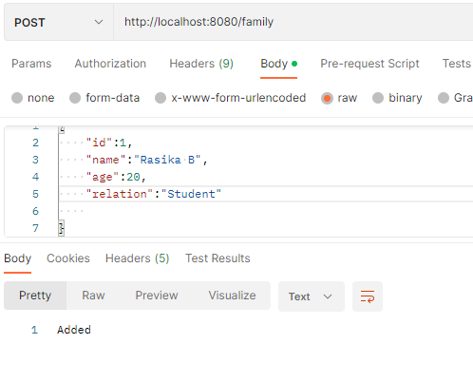

Get:

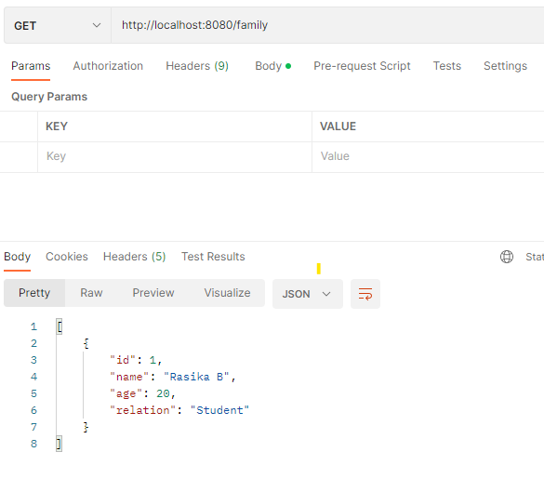

Question 4:

Controller:

package com.example.demo.controller;

import org.springframework.web.bind.annotation.RequestMapping;

import org.springframework.web.bind.annotation.RestController;

@RestController

public class Name {

private String YourName="Rasika";

@RequestMapping("/name")

public String name()

{

return "Hi "+YourName+"!";

}

}

Output:

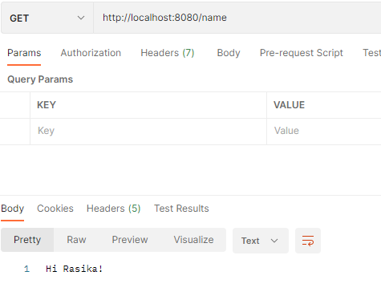

Question 5:

Controller:

package com.example.demo.controller;

import java.util.List;

import org.springframework.beans.factory.annotation.Autowired;

import org.springframework.web.bind.annotation.DeleteMapping;

import org.springframework.web.bind.annotation.GetMapping;

import org.springframework.web.bind.annotation.PathVariable;

import org.springframework.web.bind.annotation.PostMapping;

import org.springframework.web.bind.annotation.PutMapping;

import org.springframework.web.bind.annotation.RequestBody;

import org.springframework.web.bind.annotation.RestController;

import com.example.demo.model.Student;

import com.example.demo.service.ApiService;

@RestController

public class ApiController {

@Autowired

ApiService service;

@PostMapping("/stu")

public String addStudent(@RequestBody Student student)

{

return service.addStudent(student);

}

@GetMapping("/stu")

public List<Student> read()

{

return service.getStudent();

}

}

Model:

package com.example.demo.model;

import jakarta.persistence.Entity;

import jakarta.persistence.Id;

@Entity

public class Student {

@Id

private int id;

private String studentName;

private String departmentName;

private String section;

private long mobile;

private String mailid;

private String address;

public int getId() {

return id;

}

public void setId(int id) {

this.id = id;

}

public String getStudentName() {

return studentName;

}

public void setStudentName(String studentName) {

this.studentName = studentName;

}

public String getDepartmentName() {

return departmentName;

}

public void setDepartmentName(String departmentName) {

this.departmentName = departmentName;

}

public String getSection() {

return section;

}

public void setSection(String section) {

this.section = section;

}

public long getMobile() {

return mobile;

}

public void setMobile(long mobile) {

this.mobile = mobile;

}

public String getMailid() {

return mailid;

}

public void setMailid(String mailid) {

this.mailid = mailid;

}

public String getAddress() {

return address;

}

public void setAddress(String address) {

this.address = address;

}

@Override

public String toString() {

return "Student [id=" + id + ", studentName=" + studentName + ", departmentName=" + departmentName

+ ", section=" + section + ", mobile=" + mobile + ", mailid=" + mailid + ", address=" + address + "]";

}

}

Repository:

**package** com.example.demo.repository;

**import** org.springframework.data.jpa.repository.JpaRepository;

**import** org.springframework.stereotype.Repository;

**import** com.example.demo.model.Student;

@Repository

**public** **interface** StudentRepository **extends** JpaRepository<Student,Integer>{

}

Service:

**package** com.example.demo.service;

**import** java.util.List;

**import** org.springframework.beans.factory.annotation.Autowired;

**import** org.springframework.stereotype.Service;

**import** com.example.demo.model.Student;

**import** com.example.demo.repository.StudentRepository;

@Service

**public** **class** ApiService {

@Autowired

StudentRepository repository;

**public** String addStudent(Student student) {

repository.save(student);

**return** "Added";

}

**public** List<Student> getStudent() {

**return** repository.findAll();

}

}

Output:

Get:



Post:

